NAME:
Mini Test Answer Sheet:

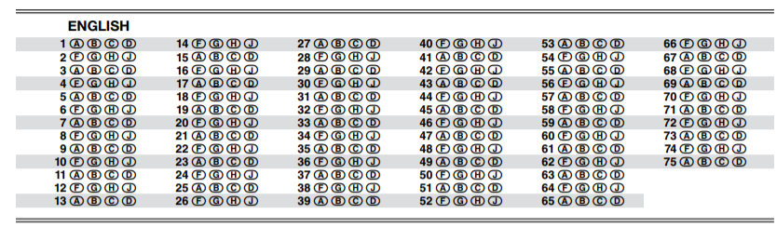
Record the number correct for each test passage:
1: 2: 3: 4:

Lesson One: Student Conversion Chart
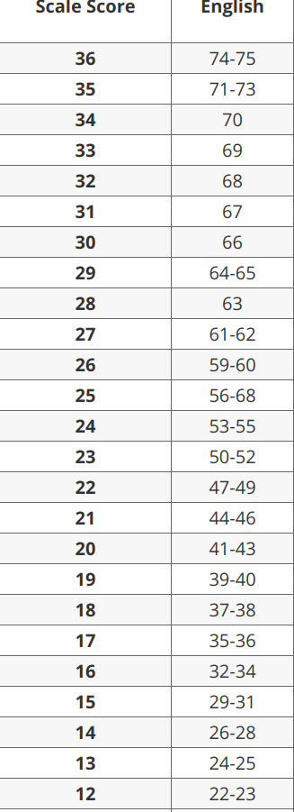
Cherry Picking:
Spend time on the sweetest questions (those most likely to yield points), and refuse to spend time on questions that will bear no fruit until all questions in the section have been answered.

Pace: Do not use more time than you are supposed to for each passage. For English, you should use 8 minutes per passage. Practice spending 8 minutes per passage to get used to the time, and then only use that amount of time per passage on the test. This will give you MORE correct answers, and that is the goal.

Stamina: The test is about being able to show that you can last for an extended time on the test. This takes PRACTICE. You have to motivate yourself to remain focused in order to do your best. Eat a good breakfast, and make sure to eat a snack during the break to recharge your battery, and DON’T GET COMPLACENT.

Sequence:
You can complete the questions in whatever order you want to complete them. Answer the easiest questions or the most interesting passages FIRST. Remember, the goal is to answer the most correct possible!
SEMICOLONS: Semicolons will ONLY be used to combine two independent clauses. If you CANNOT replace a semicolon with a period, then it is most likely incorrect. What is the correct answer for the following example:
These untruths-- whether deliberate exaggerations or slips of memory-- ultimately matter very little, for the autobiography isn’t about Mary Harris Jones.
- NO CHANGE
- little. For
- little; for
- little,

By 1900, the white-haired, calico-frocked figure was no longer known as Mary Harris Jones, the media, union leaders and workers, and even U.S. presidents referred to her as Mother Jones.
- NO CHANGE
- Jones, in fact,
- Jones in fact
- Jones
COLONS CAN ONLY BE USED AFTER AN INDEPENDENT CLAUSE (sentence part that can stand alone).
Can you replace the -- with a colon? Why or why not?
Although these snowflakes appear to have a triangular shape-- they actually have a hexagonal pattern.

When determining the correct answer, it can be useful to eliminate the other options to help determine the correct answer. How can you eliminate the answers for this question to help find the correct answer?

The triangular shape is an illusion resulting from one significant addition to the process dust.

- NO CHANGE
- process is
- process;
- process:
NO SOLO COMMAS
There can never just be one comma between the subject and the verb. There can be two commas or no commas, but never just one comma between the S and V.
To use the strategy, you need to take care in identifying the subject and verb of the sentence.
What answer choices can you eliminate using this strategy in the following example:

In the early 1950s, a twelve-year-old boy named Juan Quezada, gathered firewood in the mountains near the village of Mata Ortiz in Chihuahua, Mexico.
- NO CHANGE
- boy named Juan Quezada
- boy, named Juan Quzada
- boy named Juan Quezada

WHEN IN DOUBT, COMMAS OUT
If you must guess, lean towards the choice with the fewer commas.

Tourists and New Yorkers alike regularly filling this theater to its 900-seat capacity.

- NO CHANGE
- alike, regularly filling
- alike, regularly fill
- alike regularly fill

Fascinated by the geometric designs, Quezada wondered, if he could make pots like these?
- NO CHANGE
- wondered if he could make pots like these.
- wondered, if he could make pots like these.
- wondered if he could make pots like these?

